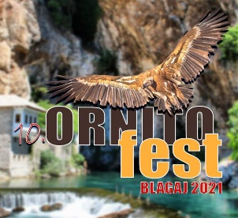

Registration form for 10thOrnithofestival
22-24 October2021, Blagaj , Bosnia and Herzegovina

Personal data

Mr. / Ms
Name and surname
Organization/institution
Address:
Telephone:
E-mail:

Do you need accommodation during the Ornithofestival? Yes No

Accomodation options

Single room
Double room
Sharing a room with (name andsurname)

Way of travelling

Plane |  | Arrival (date, time, airport)
 |  | Departure (date, time, airport)
Car |  | Arrival (date, time)
 |  | Departure (date, time)
Bus |  | Arrival (date, time)
 |  | Departure (date, time)

Way of presentation

Poster |  | Title
Oral |  | Title
No paper

Dietary requirements: Vegan Vegetarian Other (please indicate)_____________________

ABSTRACT FORM

TITLE
Author(s)
Full name(s) and surname(s)
Organization/institution
Please link the authors’ names with their respective institutions
Up to 300 words

Key words:
Up to 5 words

Abstracts should be written in one of official languages of Bosnia and Herzegovina (Bosnian, Serbian, Croatian) and English

Please submit the form until 20.09.2021. to ekohubblagaj@gmail.com

